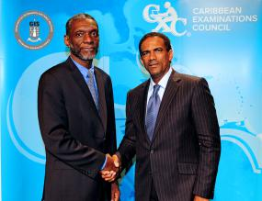
Deputy Premier and Minister for Natural Resources and Labour, Dr. the Honourable Kedrick D. Pickering (right) pictured with CXC Registrar, Mr. Glenroy Cumberbatch (left)
Cleveland L. Sam

